
T60 User Manual


Shenzhen Rtelligent Mechanical Electrical Technology Co., Ltd.
Contents
1. Product Overview 3
2. Application Environment and Installation 4
2.1 Environmental requirement 4
2.2 Drive installation dimensions 5
3. Drive Port and Connection 5
3.1 Port function description 5
3.2 Power supply input 6
3.3 Encoder connection 7
3.4 Motor connection 7
3.5 Control signal connection 8
3.5.1 PUL, DIR Port: connection for pulse command 8
3.5.2 ENA port: enable/disable 8
3.5.3 ALM port: alarm output 8
3.5.4 Control signal wiring example 9
3.6 RS232 serial port 10
4. The setting of DIP switches and operating parameters 10
4.1 The setting of pulse per revolution 11
4.2 Motor direction selection 11
4.3 Pulse filtering function selection 12
4.4 Pulse mode selection 12
4.5 Bandwidth selection 12
5. Drive working status LED indication 12
6. Common Faults and Troubleshooting 13
Appendix A. Guarantee Clause 14

1. Product Overview
Thank you for choosing Rtelligent T series digital stepper servo drive.

Stepper servo is a stepper motor scheme formed based on the common open loop stepper motor in combination with position feedback and servo algorithm, which features high speed, high torque, high precision, low vibration, low heating and no lost step.
Based on the TI new 32-bit DSP processing chip platform, and adopting the field oriented control (FOC) and field-weakening control algorithm design in servo drive, the T series stepper servo drive surpasses the performance of common steppers comprehensively.
The built-in PID parameter adjustment function makes the motor better meet the application of different kinds of loads.
The built-in field-weakening control algorithm makes the motor to reduce the magnetic field characteristics and keep the power at high speed.
The built-in current vector control function makes the motor have the current characteristic of servo and low heating.
The built-in micro-stepping command algorithm makes the motor can run while maintaining a stable and low vibration at various speeds.
The encoder feedback with the built-in 4000 pulse resolution makes the positioning precision increase and never loses the step.
In conclusion, combined with the servo control scheme with stepper motor characteristics, T series stepper servo drive can enable the stepper motor to perform a better performance and replace servo applications of the same power so it's the most cost-effective option for automatic equipment.
T60 drive can set up micro-stepping and other parameters with DIP switch and testing software. It has protection functions of voltage, current and position, and adds alarm output interface. Its input and output signals are all optoelectronic isolation.

Power supply | 24 –50 VDC
Current | 6A
Control precision | 4000 Pulse/r
Pulse mode | Direction & pulse, CW/CCW double pulse, A/B orthogonal pulse
Current control | Servo vector control algorithm
Micro-stepping settings | DIP switch settings, 15 options (or testing software settings)
Speed range | Conventional 1200 ~ 1500rpm, up to 4000rpm
Resonance suppression | Automatically calculate the resonance point and inhibit the IF vibration
PID parameter adjustment | Test software to adjust motor PID characteristics
Pulse filtering | 2MHz digital signal processing filter
Alarm output | Over current, over voltage and position error

We hope that our products with excellent performance can help you to complete the sports control program successfully.
Please read this technical manual before using the products.

2. Application Environment and Installation

2.1 Environmental requirement

Item | Rtelligent T60
Installation environment | Avoid dust, oil and corrosive environment
Vibration | 0.5G（4.9m/s²） Max
Operating temperature/humidity | 0℃ ~ 45℃ / 90% RH or less (no condensation)
Storage and transportation temperature: | -10℃ ~ 70℃
Cooling | Natural cooling / away from the heat source
Waterproof grade | IP54

2.2 Drive installation dimensions
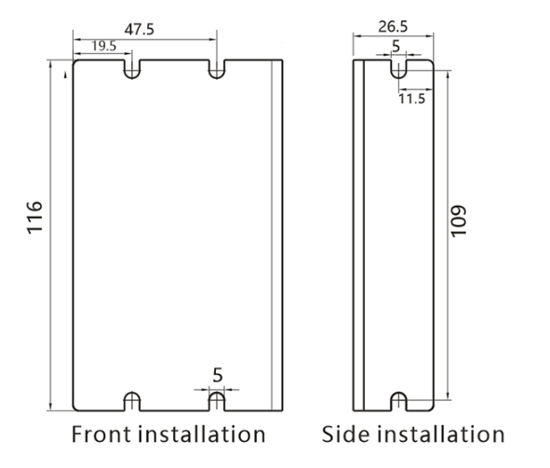

2.3 Drive installation requirements
Please install the drive vertically or horizontally, with its front facing forward, top facing upward to facilitate cooling.
During assembly, avoid drillings and other foreign matters falling inside the drive.
During assembly, please use M3 screw to fix.
When there is vibration source (such as a driller) close to the installation position, please use a vibrating absorber or a vibration resistant rubber gasket.
When multiple drives are installed in the control cabinet, please pay attention to reserve enough space for sufficient heat dissipation. If necessary, you can configure cooling fans to ensure good heat dissipation conditions in the control cabinet.

3. Drive Port and Connection

3.1 Port function description

Function | Grade | Definition | Remarks
Power supply input | V+ | Input to the positive pole of the DC power supply | DC 24~50V
Power supply input | V- | Input to the negative pole of the DC power supply | DC 24~50V
Power supply input | NC | Not connected/undefined
Motor connection | A+ | Positive terminal of phase-A winding | Red
Motor connection | A- | Negative terminal of phase-A winding | Blue
Motor connection | B+ | Positive terminal of phase-b winding | Green
Motor connection | B- | Negative terminal of phase-b winding | Black
Encoder connection | EB+ | Positive terminal of Encoder phase B | Green
Encoder connection | EB- | Negative positive terminal of Encoder phase B | Yellow
Encoder connection | EA+ | Positive terminal of Encoder phase A | Brown
Encoder connection | EA- | Negative positive terminal of Encoder phase A | White
Encoder connection | VCC | Encoder working power 5V positive | Red
Encoder connection | GND | Encoder working power 5V ground terminal | Blue
Pulse connection | PUL+ | Pulse input interface | 3.3 ~ 24V level compatible
Pulse connection | PUL- | Pulse input interface | 3.3 ~ 24V level compatible
Pulse connection | DIR+ | Direction input interface | 3.3 ~ 24V level compatible
Pulse connection | DIR- | Direction input interface | 3.3 ~ 24V level compatible
Enable terminal | ENA+ | Enable control interface | 3.3 ~ 24V level compatible
Enable terminal | ENA- | Enable control interface | 3.3 ~ 24V level compatible
Alarm output | ALM+ | Alarm output interface | Less than 24V, 40mA
Alarm output | ALM- | Alarm output interface | Less than 24V, 40mA
Output | PEND | In position output | 24V, below 40mA
Output | EXGND | Output common ground | 24V, below 40mA

3.2 Power supply input
The power supply of the drive is DC power, and the input voltage range is between 24V~ 50V.
Do not mistakenly connect the power supply to the NC pin, and do not reversely connect the polarity of the input power! ! !

Power selection reference:
Voltage:
The stepper motor has the characteristic of torque decreasing as the motor speed increases, and the voltage of the input power supply will affect the declining amplitude of the motor torque at high speed. Increasing the voltage of the input power supply appropriately can increase the output torque of the motor at high speed.
Stepper servos have higher revolution speed and torque output than ordinary steppers. Therefore, if the better high-speed performance is wanted, the power supply voltage of the drive is required to increase.
Current:
The work of the drive is to convert the input power supply with high voltage and low current to the low voltage and high current at both terminals of the motor winding.In actual application, the appropriate power supply is selected according to the motor mode and the torque of the load.
The effects of regeneration voltage:
When the stepper motor is working, it also keeps the characteristics of the generator. At deceleration, the kinetic energy accumulated by the load is converted into electric energy, which will be superimposed on the drive circuit and the input power. In application, attention should be paid to the setting of acceleration and deceleration time to prevent the protection of the drive or power supply.
When the drive is powered off, similarly, the drive LED indicator will be on if the load is increased to allow the motor to move

3.3 Encoder connection
The T60 encoder is A/B differential output and is connected in the corresponding order when used.
EB+ | EB- | EA+ | EA- | VCC | GND
Green | Yellow | Brown | White | Red | Blue

Rtelligent also provides a certain length of special cables for encoders. Please purchase the extension cables of different lengths according to the installation needs.

3.4 Motor connection
The matching motor of the T60 drive is the corresponding T series stepper servo motor, and its corresponding motor connection order is fixed and unique.
 | Nema 23/24 Motor | Nema 17 Motor
A+ | Red | Black
A- | Blue | Red
B+ | Green | Blue
B- | Black | Yellow
4-wire motor

3.5 Control signal connection

3.5.1 PUL, DIR Port: connection for pulse command
The signal interface of standard T series drive is pulse-shaped, and the T60 can receive three types of pulse command signals.
The upper controller can be the pulse signal generating device, such as PLC, MCU, control card and controller.

Pulse and direction (PUL + DIR) | Forward  Reverse
Double pulse (CW +CCW) | Reverse  Forward
Orthogonal pulse (A/ B orthogonal pulse) | Reverse  Forward

3.5.2 ENA port: enable/disable
When the default optocoupler is off, the drive outputs the current to the motor. When the internal optocoupler is on, the drive will cut off the current of each phase of the motor so that the motor is in a free state, and the stepper pulse can not be responded.
When the motor is in the wrong state, the port enables automatic disconnection. The level logic of the enable signal can be set to the opposite.

3.5.3 ALM port: alarm output
The ALM port is used to output the drive operating status to the external control circuit. ALM outputs different optocoupler levels respectively when the drive is in wrong state and normal operation state.

3.5.4 PEND: In position output
The PEND status indicates that the position error of the driver is within a certain value. When the real-time error of the driver is lower than a small value (such as 10 pulses), the driver outputs a PEND signal to the outside.
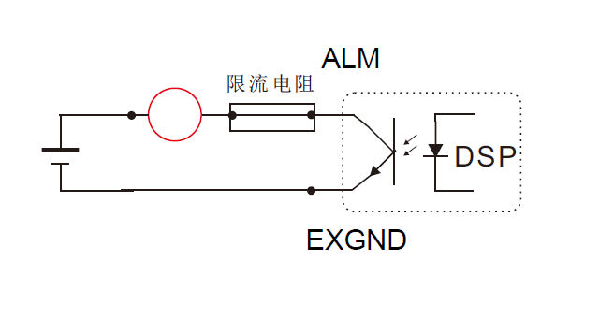
The red circle in the figure represents the switching load, which is generally used for relay or optocoupler input.
When using, pay attention to the voltage of the power supply and the use of the current limiting resistor to ensure that the output of the driver works normally!

3.5.5 Control signal wiring example
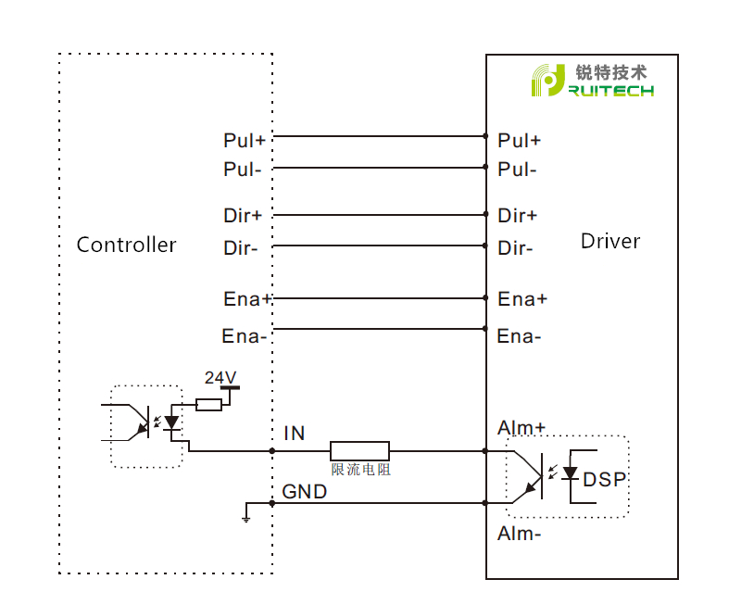

3.6 RS232 serial port
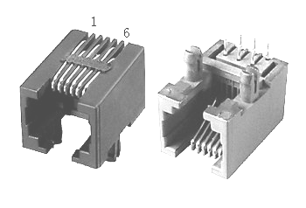 | S/N | Symbol | Description
 | 1 | NC
 | 2 | +5V | Positive terminal of power supply
 | 3 | TxD | RS232 transmitting terminal
 | 4 | GND | Ground terminal of power supply
 | 5 | RxD | RS232 receiving terminal
 | 6 | NC
RS232 serial port is used to connect T60 testing software and change other related operating parameters of drive.
Do not pull/insert 232 serial port when the power supply is connected! ! !

4. The setting of DIP switches and operating parameters
Setting stepping of level number | SW1-SW4, the four DIP switches, are used for selection of the 16 micro-stepping levels in total. Please set the correct micro-stepping levels in reference to the description of drive panel; other micro-stepping levels can be modified via testing software after turning all SW1-SW4 on.
Setting of running direction | SW5 is used for selection of an initial running direction for the motor. The setting can become valid after the drive is powered off and restarted.
Selection of pulse smoothing | SW6 is used for selection of whether to enable the internal type S command smoothing function. On means that the function is enabled to make the input pulse signal of the drive smoother. The setting can become valid after the drive is powered off and restarted.
Pulse mode selection | SW7 is used for selection of the input pulse mode, with Off referring to the pulse & direction and on the double pulse. It can also be modified as the orthogonal pulse mode via the testing software. The setting can become valid after the drive is powered off and restarted.

4.1 The setting of pulse per revolution
Stepping count/revolution | SW1 | SW2 | SW3 | SW4 | Remarks
Default | on | on | on | on | The DIP switch is turned to the Default state and the testing software can freely change other micro-stepping level number
800 | off | on | on | on
1600 | on | off | on | on
3200 | off | off | on | on
6400 | on | on | off | on
12800 | off | on | off | on
25600 | on | off | off | on
51200 | off | off | off | on
1000 | on | on | on | off
2000 | off | on | on | off
4000 | on | off | on | off
5000 | off | off | on | off
8000 | on | on | off | off
10000 | off | on | off | off
20000 | on | off | off | off
40000 | off | off | off | off
DIP SW1, SW2, SW3, SW4 are used to set the number of pulse needed for per motor revolution
Motor speed = command pulse frequency / pulse per revolution
Motor stroke = number of command pulses / pulse per revolution

4.2 Motor direction selection
DIP SW5 is used to set the running direction of the motor under the initial pulse.
The “off” means that the motor direction is counterclockwise when inputting the initial pulse;
The “on” means that the motor direction is clockwise when inputting the initial pulse.
※ The initial pulse is the testing pulse used when developing the drive software; Please refer to the actual running direction of the motor.

4.3 Pulse filtering function selection
DIP SW6 is used to set the pulse filtering function of drive.
The “off” means the pulse filtering function is off;
The “on” means the pulse filtering function is on.
※ The pulse filtering function is the filtering action by the drive upon the input commands. When the filtering function is on, the drive will smoothen the input pulse command to make the acceleration and deceleration of motor softer, but this will also cause certain delay of the pulse command.
Filtering time setting: The default time of filtering function is 6.4ms, and the software can change the time below the 25.6ms.

4.4 Pulse mode selection
DIP SW7 is used to set the driver pulse command mode.
Off means pulse + direction (single pulse) mode; on means double pulse mode.
※ When you need to set the drive pulse mode to A / B quadrature pulse mode, you need to set the pulse mode check function to A / B quadrature pulse mode in the debugging software and set SW7 to on.

4.5 Bandwidth selection
DIP SW8 is used to set the input pulse frequency bandwidth of the driver.
“ off ” means the maximum input pulse frequency bandwidth is 200KHz;
“ on ” means that the maximum input pulse frequency bandwidth is 1MHz.
※ When you need to set the input pulse frequency bandwidth to other values (less than 2MHz), you need to set the input pulse frequency bandwidth check function to the value you need in the debugging software and set SW8 to on.
※ The above parameters are set for the DIP switches; For other parameters, please refer to Appendix A: Application Instructions for Testing Software

5. Drive working status LED indication
LED status |  | Drive status
 | Green indicator is on for long time | Drive not enabled
 | Green indicator is flickering | Drive working normally
 | One green indicator and one red indicator | Drive overcurrent
 | One green indicator and two red indicators | Drive input power overvoltage
 | One green indicator and three red indicators | The internal voltage of the drive is wrong
 | One green and four red indicators | Tracking error exceeds limits
 | One green and five red indicators | Encoder phase error

6. Common Faults and Troubleshooting
Phenomenon | Possible situations | Solutions
Motor does not work | Power indicator is off | Check the power supply circuit for normal power supply
Motor does not work | The motor rotor is locked but the motor does not work | Pulse signal is weak; increase the signal current to 7-16mA
Motor does not work | The speed is too slow | Select the right micro-stepping
Motor does not work | Drive is protected | Solve the alarm and re-power
Motor does not work | Enable signal problem | Pull up or disconnect the enable signal
Motor does not work | Command pulse is incorrect | Check whether the upper computer has pulse output
The steering of motor is wrong | The rotary direction of motor is reverse | Adjust the DIP SW5
The steering of motor is wrong | The motor cable is disconnected | Check the connection
The steering of motor is wrong | The motor has only one direction | Pulse mode error or DIR port damaged
Alarm indicator is on | The motor connection is wrong | Check the motor connection
Alarm indicator is on | The motor connection and encoder connection are wrong | Check the sequence of encoder connection
Alarm indicator is on | The voltage is too high or too low | Check the power supply
The position or speed is wrong | The signal is disturbed | Eliminate interference for reliable grounding
The position or speed is wrong | The command input is incorrect | Check the upper computer instructions to ensure the output is correct
The position or speed is wrong | The setting of Pulse per revolution is wrong | Check the DIP switch status and correctly connect the switches
The position or speed is wrong | Encoder signal is abnormal | Replace the motor and contact the manufacturer
The drive terminal burned up | Short circuit between terminals | Check power polarity or external short circuit
The drive terminal burned up | Internal resistance between terminals is too large | Check whether there is any solder ball due to excessive addition of solder on the wire connections
The motor is out of tolerance | Acceleration and deceleration time is too short | Reduce command acceleration or increase drive filtering parameters
The motor is out of tolerance | Motor torque is too low | Select the motor with high torque
The motor is out of tolerance | The load is too heavy | Check the load weight and quality and adjust the mechanical structure
 | The current of power supply is too low | Replace the appropriate power supply

Appendix A. Guarantee Clause
A.1 Warranty period: 12 months
We provide quality assurance for one year from the date of delivery and free maintenance service for our products during the warranty period.
A.2 Exclude the following:
■ Improper connection, such as the polarity of the power supply is reversed and insert/pull the motor connection when the power supply is connected.
■ Beyond electrical and environmental requirements.
■ Change the internal device without permission.
A.3 Maintenance process
For maintenance of products, please follow the procedures shown below:
(1) Contact our customer service staff to get the rework permission.
(2) The written document of the drive failure phenomenon is attached to the goods, as well as the contact information and mailing methods of the sender.
Mailing address:
Post code:
Tel.:

