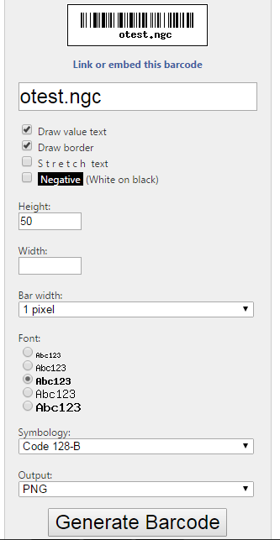

https://www.barcodesinc.com/generator/index.php

